Images in this article were generated using copilot

📖 Psalms for the Heavy Heart: A Journey Through the Valley
A 5-Module Interactive Course for Finding Light in the Shadows
Welcome to a deep dive into the "Prayer Book of the Bible." If you feel like you are walking through a dark fog, you are in good company. The Psalms were written by real people—kings, fugitives, and poets—who wrestled with clinical-level sorrow, abandonment, and bone-deep exhaustion.

🧭 Module 1: The Permission to Lament
Core Theme: God doesn’t want a "polite" version of you; He wants the real you.
In this module, we look at Psalm 13. David starts with a blunt question: "How long, Lord? Will you forget me forever?"
- The Deep Dive: We explore the anatomy of a lament. It’s not just complaining; it’s complaining to the only One who can fix it.
- Mental Health Connection: Validating your emotions is the first step toward processing them. Repression leads to explosion; lament leads to release.
- Interactive Element: * The "Lament Lab": Use the template: How long, Lord, until [Your Struggle]? But I trust in [A Character of God]. *


🌊 Module 2: When the Waves Overwhelm
Core Theme: Spiritual depression and the "Why?" of the soul.
We dive into Psalm 42 & 43. The writer says, "My tears have been my food day and night." This isn't just a bad day; it’s a soul-crushing season.
- The Deep Dive: Notice the "Self-Talk" in verse 5: "Why, my soul, are you downcast?" The Psalmist stops listening to his depressed heart and starts preaching to it.
- Practical Application: Learning to distinguish between your "feelings" and "facts."
- Interactive Challenge: * The "Pulse Check" Quiz: (Mental Health Scale) On a scale of 1-10, how loud is your "downcast soul" today? What is one "truth" you can whisper back to it?

🌑 Module 3: The Darkest Night (Psalm 88)
Core Theme: When the clouds don't lift—and that's okay.
Most Psalms end with a "Hallelujah." Psalm 88 does not. It ends with the words: "Darkness is my closest friend." * The Deep Dive: Why is this in the Bible? Because God wants you to know that He hears you even when there is no immediate "happy ending." He is present in the silence.
- Mental Health Connection: Combating the "toxic positivity" sometimes found in religious circles. It is okay to not be okay.
- Interactive Reflection:
  - The Prayer Wall: Write down a prayer that doesn't have an "Amen" yet. Sit with the silence, knowing Christ sat in the darkness of the tomb for you.


🛡️ Module 4: The Shepherd in the Shadows
Core Theme: Protection and presence in the "Valley of the Shadow of Death."
We revisit the most famous Psalm of all: Psalm 23.
- The Deep Dive: Focus on the shift in pronouns. In the green pastures, David talks about God ("He leads me"). In the valley, he talks to God ("You are with me"). The valley turns "Information" into "Intimacy."
- Practical Application: Grounding techniques using the "Rod and Staff" (Scripture and Community).
- Interactive Game:
  - "Valley Vocabulary" Kahoot! * Sample Q: In Psalm 23, what does the "Table" in the presence of enemies represent? (A) A quick snack, (B) A victory lap, (C) God’s provision and safety amidst the battle.

🌅 Module 5: The Dawn of Deliverance
Core Theme: Joy comes in the morning (even if the "morning" takes a while).
We conclude with Psalm 30 and Psalm 126. "Those who sow with tears will reap with songs of joy."
- The Deep Dive: Understanding that "reaping joy" is a harvest—it takes time, soil, and rain (tears).
- Practical Application: Building a "Stone of Help" (Ebenezer) list. What are the small ways God has sustained you this week? A warm cup of coffee? A text from a friend?
- Final Course Project: * Create Your Own Psalm: Using the themes of the last 5 modules, write a 4-line poem/prayer about your journey from the shadow toward the light.
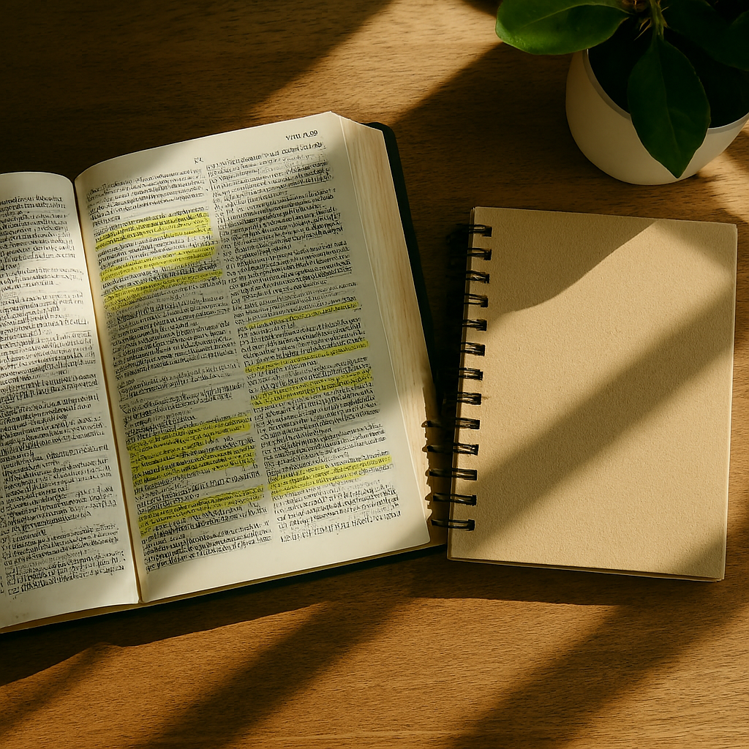

🎓 Final Assessment: The "Heart-Check" Quiz
Interactive Link: [Click here to launch the Kahoot! Challenge] (Test your knowledge on the authors of the Psalms, the types of lament, and the promises of God's presence found in the text!)

